Largest Residential Deal: 66,000 sq ft dual plots sold on Jumeirah Bay for 120M by Luxhabitat Sotheby’s International Realty

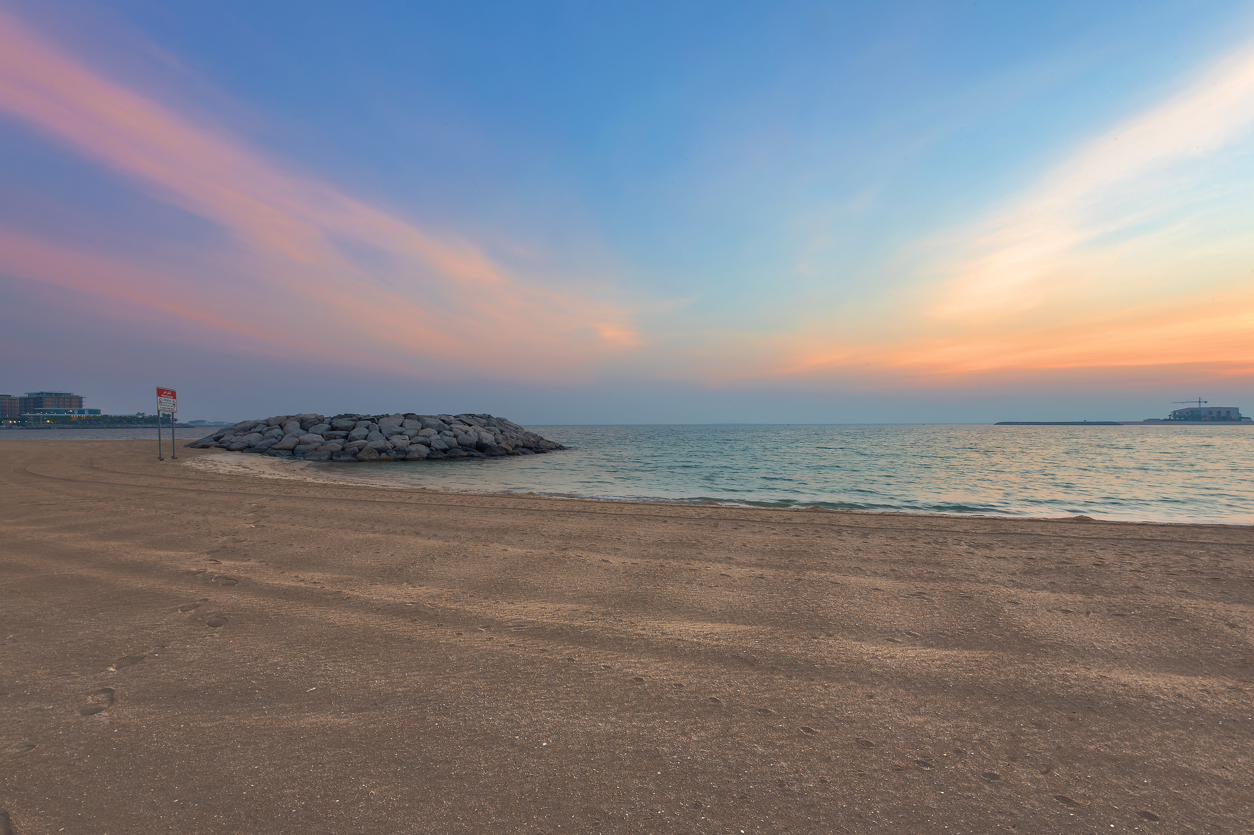
The plot is to be developed into a residential mega mansion

DUBAI, 20th OCTOBER 2021

2021 has seen a series of record-breaking sales in some of Dubai’s finest locations, especially on Jumeirah Bay Island. Luxhabitat Sotheby’s International Realty is proud to announce it has closed yet another AED 100 million plus deal, a double residential 66,000 square foot plot for Jumeirah Bay Island, making it the second most expensive residential transaction in Dubai so far (Luxhabitat Sotheby’s also currently holds the record for the most expensive property – a Jumeirah Bay Island mansion at AED 121 million).

The agent responsible for the transaction is Dr. Taieser Al Saati, Associate Director of Luxhabitat Sotheby’s International Realty. Dr Al Saati has been with Luxhabitat Sotheby’s for 4 years and has firmly cementing his position of having sold the most valuable properties this year to date as he has also sold the most expensive villa deal of the year at AED 121 million in Dubai not long ago. Dr Al Saati said, “At Luxhabitat Sotheby’s International Realty, we get to work with the world’s most extraordinary properties and working here is a dream come true - at a time when the international market is looking to us as a leading destination for investment and growth. This double plot on Jumeirah Bay Island is just the beginning, there is much more to come.”

This record-breaking sale of dual plots is the largest deal in terms of area to be completed on the island thus far. It also presents an excellent and exclusive opportunity for the anonymous buyer to take advantage of an excellent location and vast space. The two plots occupy the most coveted position on the island, and both enjoy breath-taking views over the sea and the iconic Burj Khalifa. The plots are to be developed into a state-of-the-art contemporary mega mansion by world class firm DDA and has already received approvals to be built now. Termed ‘The Kohinoor of Jumeirah Bay’, the plans for the mansion have been developed by taking the inspiration by the beautiful seaside location, sunset hues, the ocean breeze, and lush foliage with swaying Palm trees. A grand lobby features at the entrance, with awe inspiring chandeliers and a stunning view of the beach flanked by a grand staircase. Multiple gathering spaces, a spa, cinema, private swimming pool, formal & informal dining rooms, and several suite style bedrooms feature as part of the plans for the villa.

Nestled off the coast between the iconic Downtown Dubai and the famous World Islands, Jumeirah Bay Island is hosts several show-stopping residences. The island is sculpted in the shape of a titanic seahorse and, with its stunning views, is one of the most sought-after addresses in the whole of Dubai for the rich and famous. It is also home to the internationally revered Bvlgari Resort & Residences, a luxurious resort with the world’s first Bvlgari Yacht Club. Over AED 1.8 billion in sales have been recorded this year so far, based on data from the Dubai Land Department.

About LUXHABITAT Sotheby’s International Realty

Headquartered in Dubai, LUXHABITAT Sotheby’s International Realty focuses on residential and commercial luxury sales and leasing, luxury property management, institutional investments, and luxury project developments in the UAE and beyond. LUXHABITAT Sotheby’s International Realty represents the marketing and sales partnership between Sotheby’s International Realty brand in the entire GCC region and LUXHABITAT, a design-led real estate marketing and technology company. Together, we are now the biggest and strongest marketing and selling platform for luxury real estate in Dubai, making us the foremost luxury real estate brokerage in the market today. We are focused in sourcing the best quality properties in premium residential areas such as Emirates Hills, Palm Jumeirah, Al Barari, Jumeirah Islands, Jumeirah Golf Estates, Meadows, Lakes and Arabian Ranches as well as the best apartments and penthouses in upscale buildings such as Le Reve, Index Tower, Six Towers, Burj Khalifa, The Address Hotels, among others. For more information, visit its award-winning website at www.luxhabitat.ae

For further press information, images or to arrange interviews please contact Aneesha Rai
E: ar@luxhabitat.ae | M +971 50 42 60 432

