Fit for ‘Selling Sunset’: The ultra-luxury mansions being sold by Luxhabitat Sotheby’s

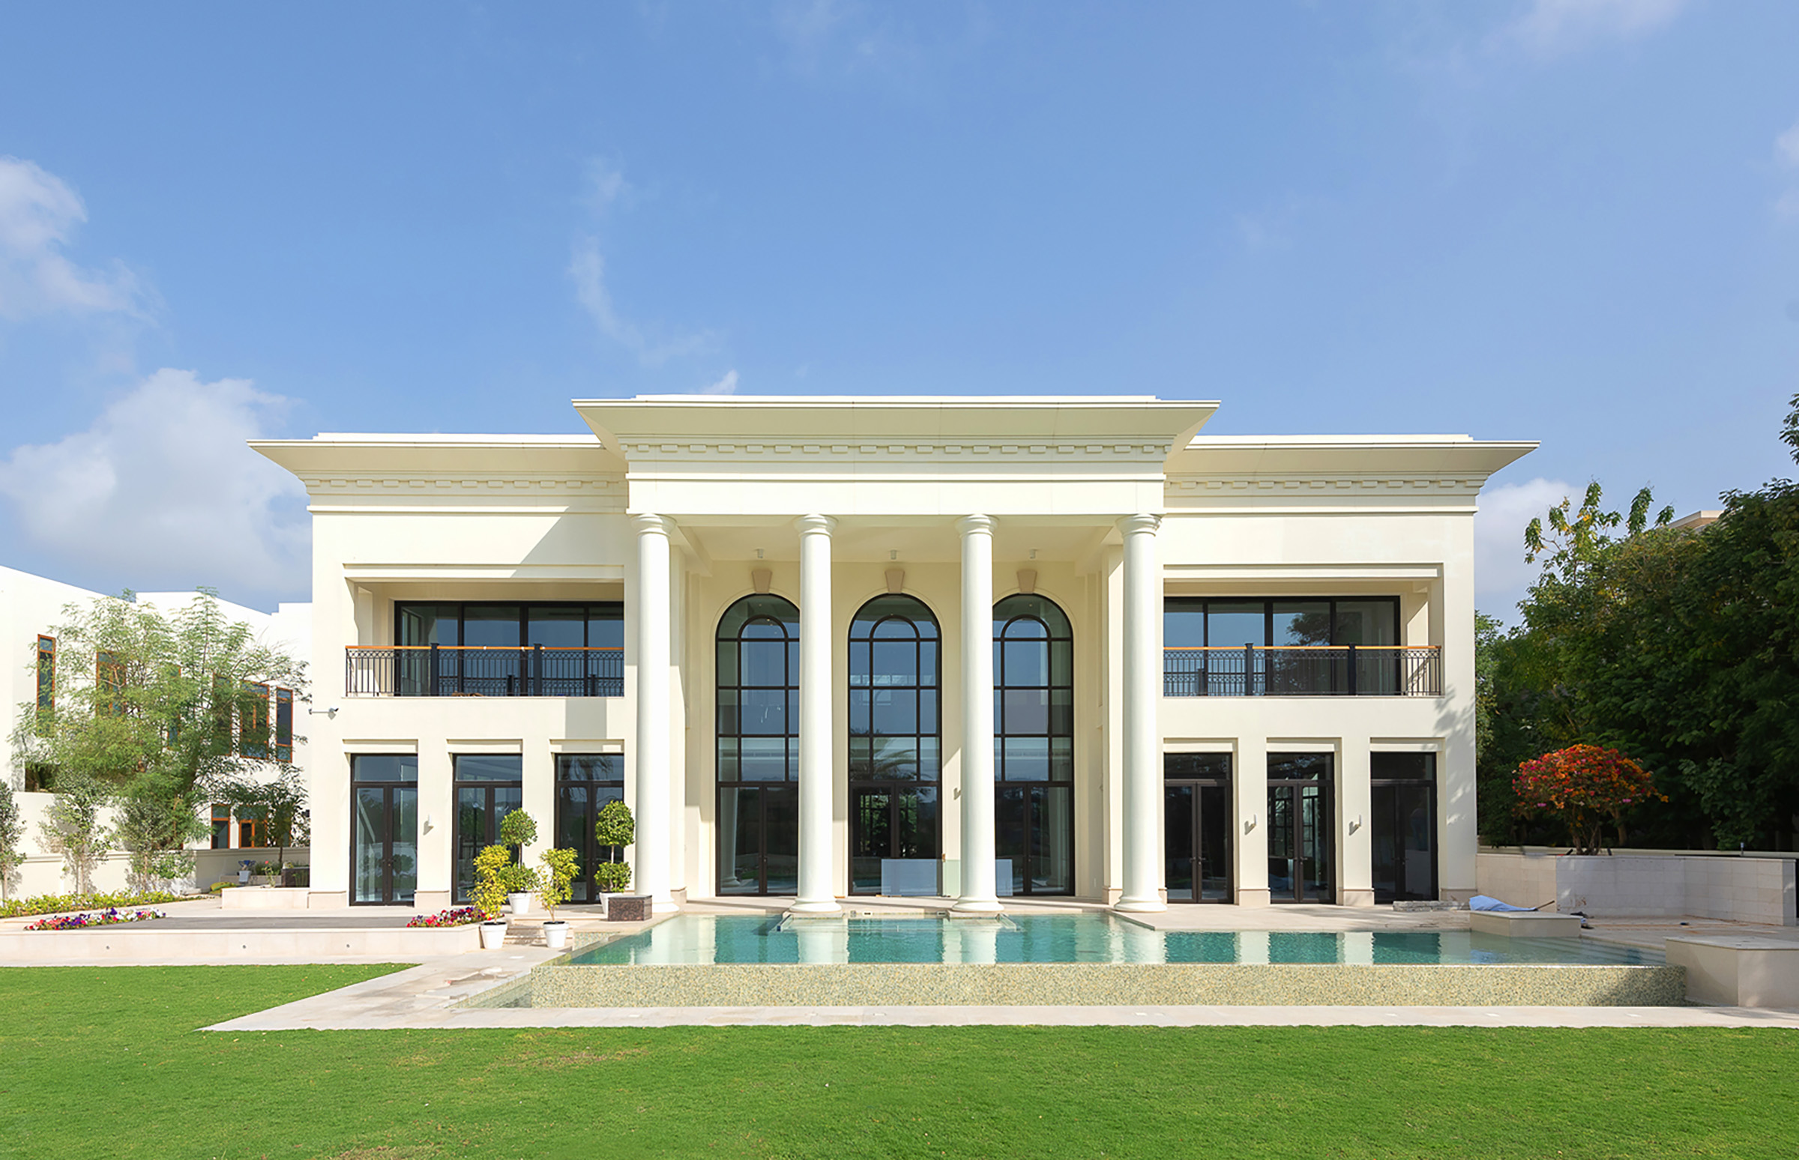
The most expensive property sold in Emirates Hills in 2021 so far
Image Courtesy: Luxhabitat Sotheby’s International Realty

DUBAI, 19TH MAY 2021

Luxhabitat Sotheby's reports to have completed numerous high-value transactions of 30 million to 75 million AED in the prestigious Emirate Hills community. The leading purveyors of luxury real estate in town reported a total worth of sales transactions by the firm of over 250 million AED in 2021, nearly double compared to the q1 & q2 periods in 2020.

Standing out amongst these transactions is a property with the most desirable address, L1 in Emirates Hills. Luxhabitat Sotheby's International Realty, also behind the record-setting One100 Palm Villa sale earlier this year, listed the property off-market and closed the transaction within 6 weeks. The property was listed and sold by Leigh Borg, Managing Director at Luxhabitat Sotheby's International Realty, who also bears the record for Top-1 & 2 sales ever in Emirate Hills, known around town as the 'Beverly Hills of Dubai'.

The well-known neighborhood continues to see high demand from high-net worth individuals and international buyers across Germany, Switzerland, France, Russia, Italy, India & GCC. International buyers see Dubai as a safe & stable economy to buy into particularly when it comes to investing in the large value assets available in areas like Emirates Hills, Palm Jumeirah, Al Barari and Jumeirah Bay Island. This rise in demand comes on the heels of a successful economic boost following the positive handling of the Covid-19 pandemic by UAE authorities.

The exquisite mansion sold recently was designed by world-class architects KOBI KARP and is one of the most lavish villas in Dubai with a 30,000 sq.ft. of built-up area. From the magnificent chandelier with over 500 Hand-blown glass spheres and crystal butterflies designed and executed by ‘Preciosa’ to the 50-year-old Bonsai Tree in the Atrium, every detail of the mansion was planned and executed by top-notch designers with high-class finishes, handcrafted materials and custom-made furnishings; making it well worth the high price tag.

"Completing the high-value transactions of ultra-luxury mansions like this with such consistency is evidence of the coveted relationships we have within the luxury property sector" said George Azar, the Chairman & CEO at Luxhabitat Sotheby's International Realty. “We have multiplied transactions in the luxury secondary market segment by 3x folds compared to the whole term of 2020”, he added.

This record-breaking streak of 2021 has been heavily influenced by the soaring demand in the ultra-high-end property segment from high-end buyers and investors honing in on lucrative secondary markets.

- END OF RELEASE-

About LUXHABITAT Sotheby’s International Realty

Headquartered in Dubai, LUXHABITAT Sotheby’s International Realty focuses on residential and commercial luxury sales and leasing, luxury property management, institutional investments, and luxury project developments in the UAE and beyond. LUXHABITAT Sotheby’s International Realty represents the marketing and sales partnership between Sotheby’s International Realty brand in the entire GCC region and LUXHABITAT, a design-led real estate marketing and technology company. Together, we are now the biggest and strongest marketing and selling platform for luxury real estate in Dubai, making us the foremost luxury real estate brokerage in the market today. We are focused in sourcing the best quality properties in premium residential areas such as Emirates Hills, Palm Jumeirah, Al Barari, Jumeirah Islands, Jumeirah Golf Estates, Meadows, Lakes and Arabian Ranches; and also, the best apartments and penthouses in upscale buildings such as Le Reve, Index Tower, Six Towers, Burj Khalifa, The Address Hotels, among others. For more information, visit our award-winning website at www.luxhabitat.ae

For further press information, images or to arrange interviews please contact Aneesha Rai
E: ar@luxhabitat.ae | M +971 50 42 60 432

